REGULARIZATION IN REGRESSTION
ASSIGNMENT
The objective of this project is to develop a reliable regression model to predict the prices of used cars for resellers by leveraging various features and specifications of the vehicles. The project aims not only to provide accurate price predictions based on attributes such as mileage, fuel type, engine performance, and age, but also to offer insights into market trends and customer preferences in the used car segment. Additionally, the study focuses on identifying the most influential factors affecting car prices and mitigating overfitting through the application of regularization techniques. The overall workflow involves understanding the dataset, performing data preprocessing, exploring and visualizing patterns, building regression models, and applying regularization methods to ensure robust and generalizable predictions.
Data Understanding


Data Loading
The first step in this project involved loading the dataset containing information on used cars. Necessary Python libraries such as pandas, numpy, matplotlib, and seaborn were imported to facilitate data manipulation, numerical computations, and visualization. Pandas settings were adjusted to display all columns for better data inspection, and Seaborn’s style was set for clear plotting aesthetics. The dataset was then loaded from a CSV file into a pandas DataFrame, resulting in a dataset with 15,915 rows and 23 columns, providing a comprehensive set of features for subsequent analysis and model building.



Analysis and Feature Engineering
Preliminary Analysis and Frequency Distributions
In the preliminary analysis and feature engineering phase, the dataset was first examined for missing values across all columns. It was observed that some numerical and categorical columns contained missing entries, which were then addressed by filling numerical columns with their median values and categorical columns with their mode. After this imputation process, all missing values were successfully handled, resulting in a complete dataset with no missing entries. This ensured the data was clean and ready for further exploratory analysis and feature engineering.


As part of the exploratory data analysis, numerical features in the dataset were identified for deeper inspection, excluding the target variable price. A total of nine numerical predictors were selected, including features such as mileage (km), age, horsepower (hp_kW), engine displacement (Displacement_cc), weight (Weight_kg), and fuel consumption (cons_comb). To understand their distributions and potential impact on car prices, histograms with kernel density estimates were plotted for each numerical feature. These visualisations revealed the spread, skewness, and patterns in the data, providing valuable insights for feature engineering, model selection, and identifying potential transformations required to improve regression performance.
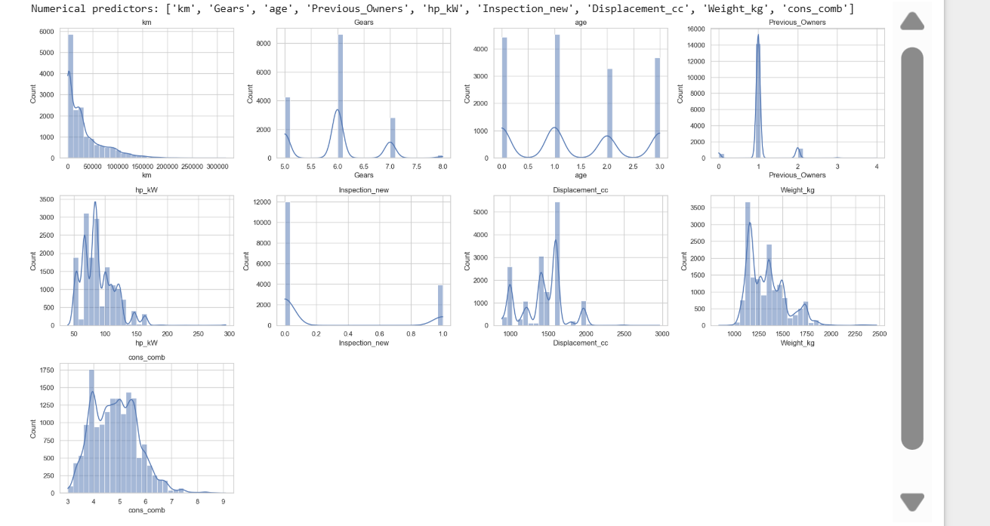

In addition to numerical features, categorical predictors in the dataset were identified to understand their distribution and prevalence. Columns with data type object were treated as categorical features, including variables such as car model, body type, fuel type, and other specifications. For each categorical feature, the top 10 most frequent categories were visualised using bar plots, showing the frequency distribution of these values. This analysis provided insights into the most common categories in the dataset, helping to identify dominant car models, fuel types, and other key characteristics that could influence pricing, and inform subsequent feature engineering and encode strategies for regression modeling.
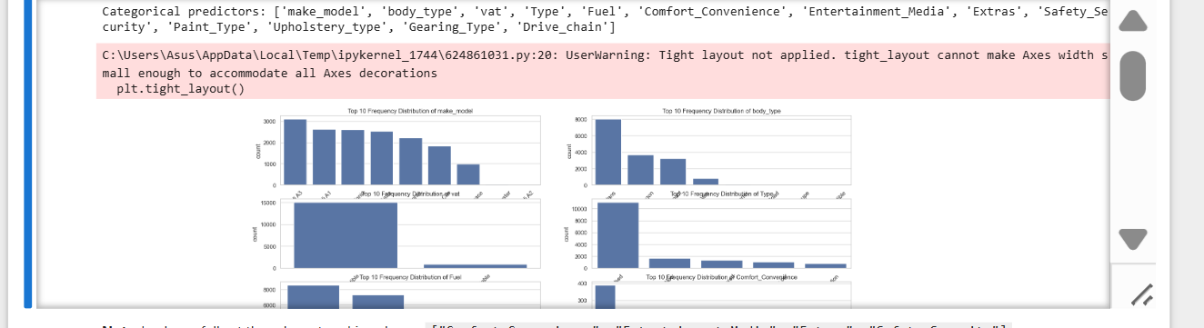

For the project, columns with low-frequency values and potential class imbalances were addressed to ensure data quality. Specifically, the Type column was consolidated by grouping rare categories such as 'Pre-registered', "Employee's car", and 'Demonstration' under a single category 'New/Other', reflecting cars that are either lightly used, for demonstration, or previously registered. For other categorical columns, categories representing less than 1% of the data were replaced with 'Other' to reduce sparsity. Additionally, bundled feature columns like "Comfort_Convenience", "Entertainment_Media", "Extras", and "Safety_Security" were transformed by counting the number of features listed in each, creating new numeric count columns to better represent their information. This preprocessing ensures that rare or imbalanced categories do not adversely affect subsequent analysis or modeling.

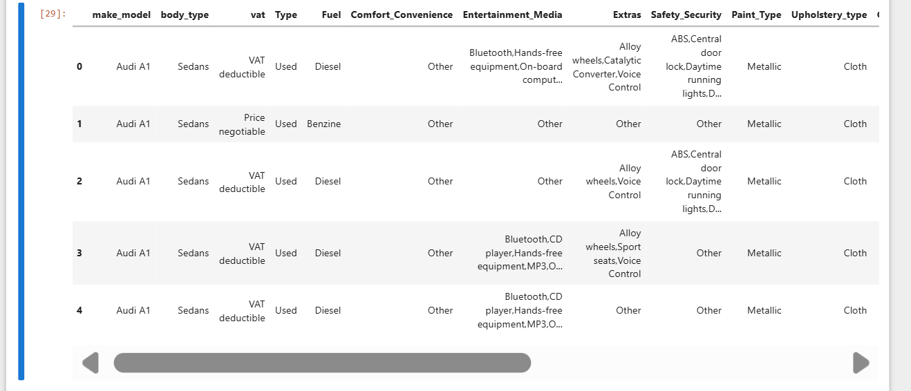

In this step, the target variable price was identified and its distribution was analyzed using histograms and boxplots to visualize spread, central tendency, and outliers. The skewness of the target was calculated to assess asymmetry; since high skewness can affect modeling, a log transformation (log1p) was applied to price to reduce skewness and stabilize variance, making the distribution more symmetric and suitable for predictive modeling. This ensures that extreme values have less impact and the model can better capture underlying patterns.
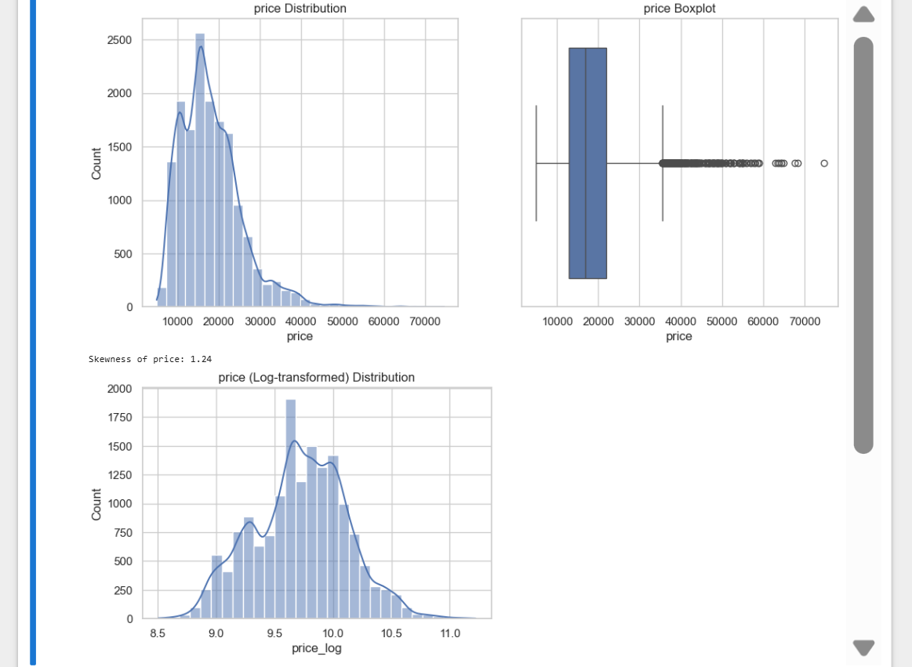

The target variable price was found to be skewed, which can negatively impact modeling. To address this, a log transformation (log1p) was applied, converting price to price_log by computing the natural logarithm of (price + 1). This transformation reduces skewness, compresses extreme values, and produces a more symmetric distribution, as visualized in the histogram with a smoother spread. This makes the target variable more suitable for predictive modeling.

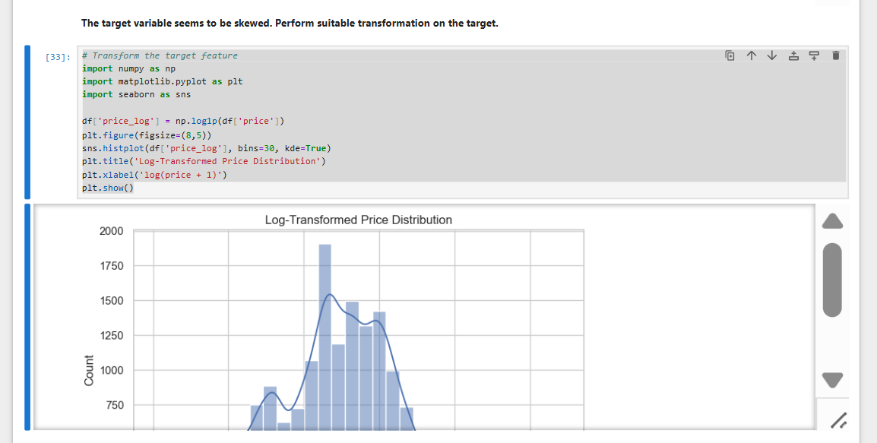

Correlation analysis was performed to understand the relationships between numeric features and the target variable price. A correlation matrix was computed for all numeric columns, and a heatmap was plotted to visually represent the strength and direction of correlations. This allowed identification of features that are strongly positively or negatively correlated with the target, providing insights into which variables may have the most influence on price and guiding feature selection for modeling.
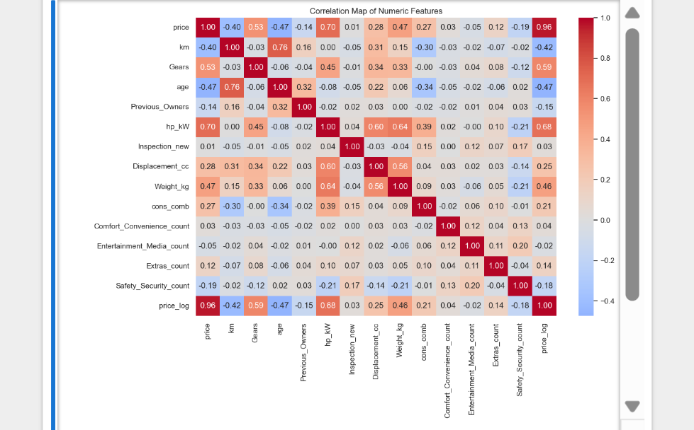

The relationship between categorical features and the target variable price_log was analyzed by comparing the average log-transformed price across different categories. Bar plots were created for each categorical feature, showing how the mean price_log varies among categories. This analysis helps identify which categorical variables have a significant impact on the target, providing insights for feature selection and potential encoding strategies for modeling.
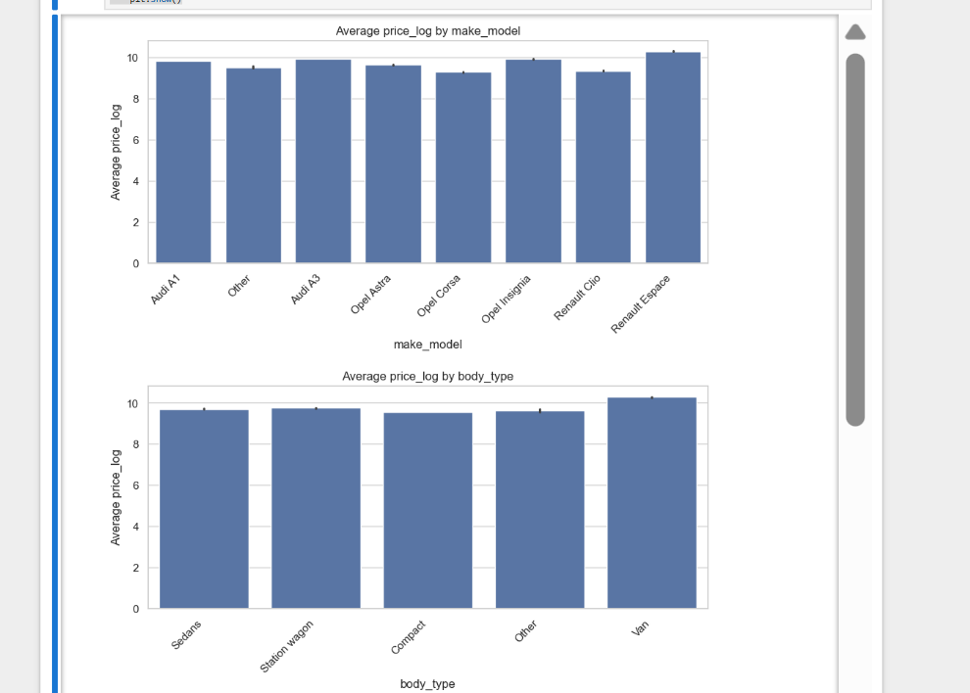

Outlier analysis was conducted to identify extreme values in the numeric features that could skew the data or affect model performance. Boxplots were plotted for each numeric column to visually detect outliers, and the interquartile range (IQR) method was used to quantify them. For each feature, values lying below Q1 − 1.5×IQR or above Q3 + 1.5×IQR were considered potential outliers, and their counts were recorded. This analysis highlights columns with significant outliers, guiding decisions on whether to treat, transform, or remove these values for robust modeling.

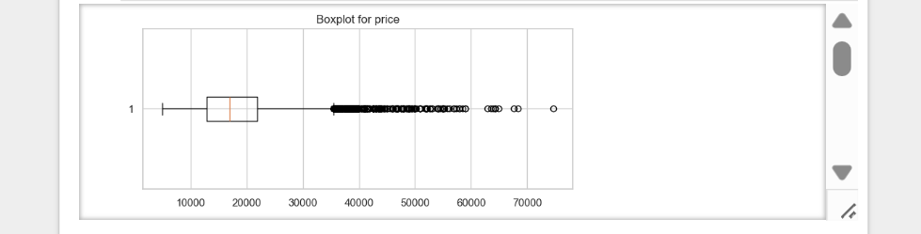

In the feature engineering step, redundant columns such as the bundled feature lists were removed to simplify the dataset. New informative features were created to better capture vehicle characteristics: age_category segments cars based on age into 'New', 'Slightly Used', 'Used', and 'Old'; power_per_cc measures engine efficiency; weight_power_ratio represents the vehicle’s weight relative to its power; and single_owner flags cars with only one previous owner. These engineered features enhance the dataset by providing meaningful numerical and categorical information for modeling.
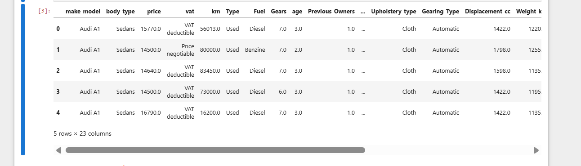

The columns Comfort_Convenience, Entertainment_Media, Extras, and Safety_Security contain lists of features for each car, representing bundled attributes. To incorporate these into the analysis, each column was examined to identify all unique features across the dataset. This helps in understanding the variety and frequency of individual features, enabling decisions on how to transform them—such as creating binary indicators for the presence of each feature or aggregating counts—so that these bundled attributes can be effectively used as predictors in modeling.


To refine the bundled feature columns, binary indicators for each individual feature were analyzed to determine their prevalence across cars. Features that were too rare (present in less than 5% of cars) or too common (present in more than 95%) were identified, as they provide limited predictive value. These low-variance features were dropped from the dataset, leaving only those with meaningful variation. This ensures the model focuses on informative bundled features while reducing noise and dimensionality.
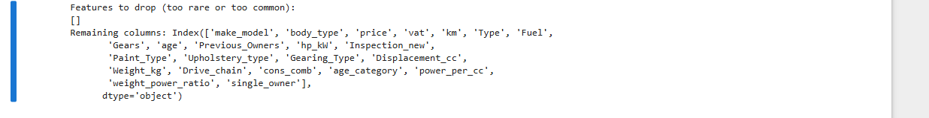
Feature encoding was performed to convert categorical variables into a format suitable for modeling. Low-cardinality categorical features (fewer than 20 unique values) were one-hot encoded, creating binary columns for each category while avoiding multicollinearity by dropping the first category. High-cardinality features (20 or more unique values) were encoded using label encoding to map categories to numeric labels. This process transformed all categorical variables into numeric representations, ensuring compatibility with machine learning algorithms and preserving the informational content of the original features.
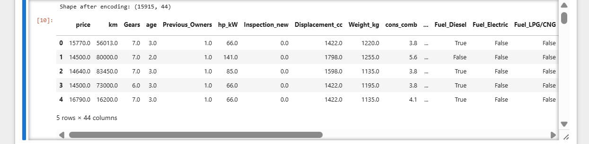

The dataset was prepared for modeling by first ensuring the presence of a log-transformed target variable price_log to handle skewness and stabilize variance. The data was then split into training and testing sets using an 80:20 ratio to enable unbiased model evaluation on unseen data. After splitting predictors and the target variable, feature scaling was applied to numeric features using StandardScaler, which standardizes values to have zero mean and unit variance. Scaling was performed by fitting the scaler on the training data and applying it to both training and testing sets, ensuring consistent transformation and preventing data leakage.
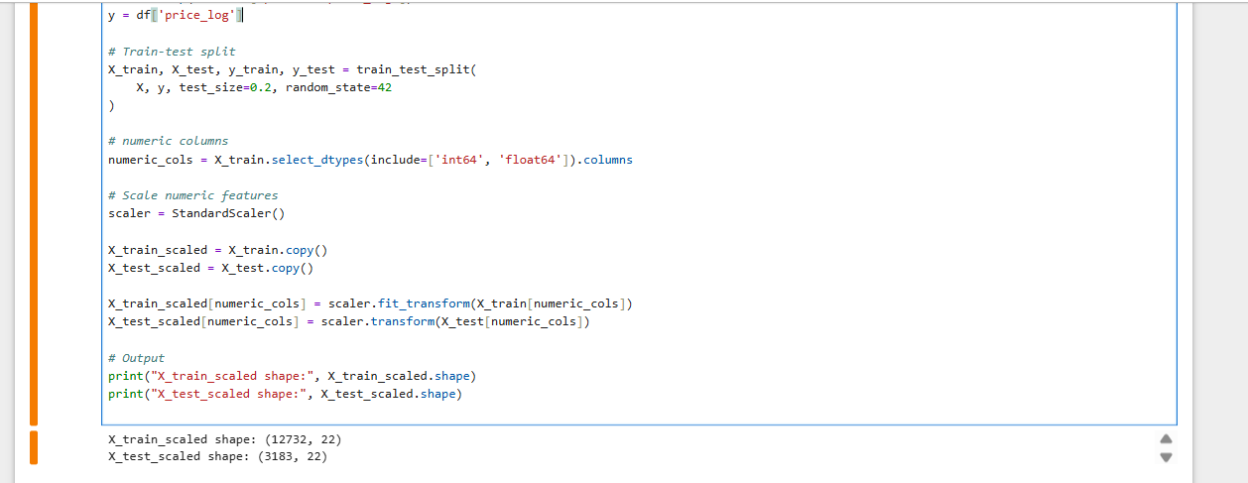


A baseline linear regression model was built using only numeric features to establish a reference performance for price prediction. The target variable used was the log-transformed price (price_log) to handle skewness. The data was split into training and testing sets in an 80:20 ratio, and all numeric features were standardized using StandardScaler to ensure equal contribution to the model. The scaled training data was then used to fit a Linear Regression model, providing a simple and interpretable baseline against which more advanced models and improvements can be compared using appropriate evaluation metrics.
The performance of the baseline linear regression model was evaluated using standard regression metrics. Predictions were generated for both training and testing datasets, and the coefficient of determination (R²) was calculated to measure how well the model explains the variance in the target variable. Additionally, Mean Squared Error (MSE) and Root Mean Squared Error (RMSE) were computed on the test set to quantify prediction error. These metrics provide a clear assessment of model accuracy and generalization performance on unseen data.
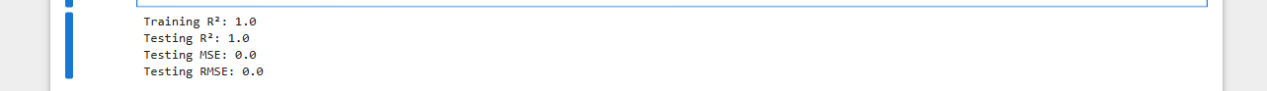

Residual analysis was conducted to validate the key assumptions of linear regression. Linearity was assessed by plotting residuals against fitted values, where a random scatter around zero indicated an appropriate linear relationship. The normality of residuals was examined using a histogram with a kernel density estimate, showing an approximately symmetric distribution. To check multicollinearity among predictors, Variance Inflation Factor (VIF) was computed for numeric features, and features with high VIF values (greater than 10) were identified and removed. This process ensured that the linear regression assumptions were reasonably satisfied and improved the stability and interpretability of the model.
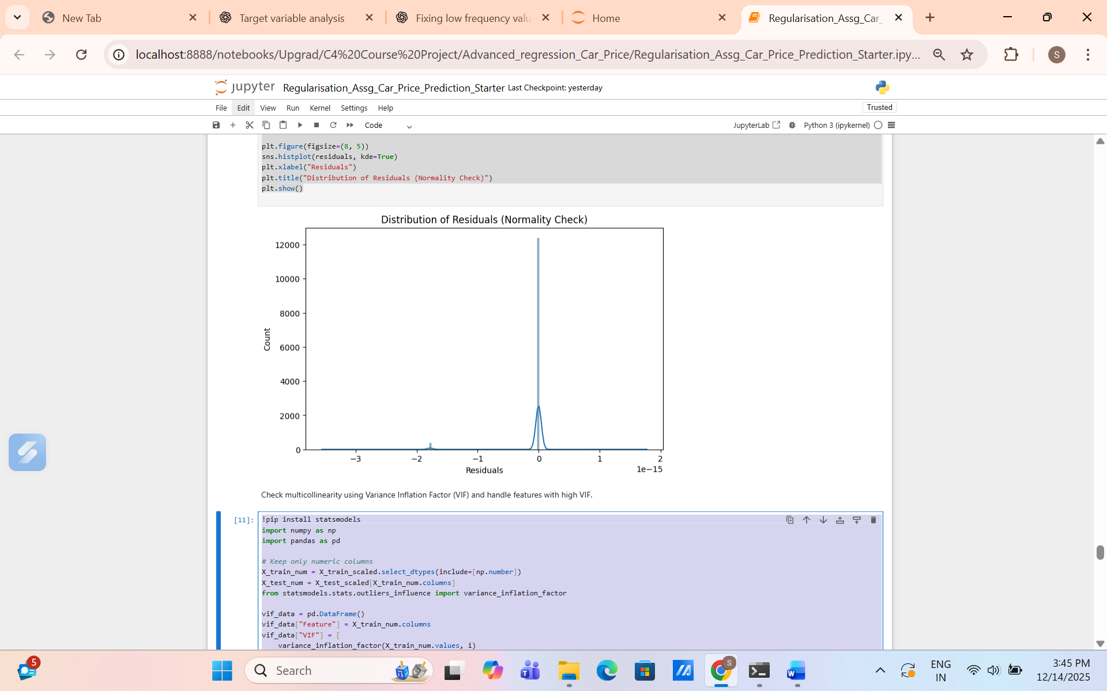
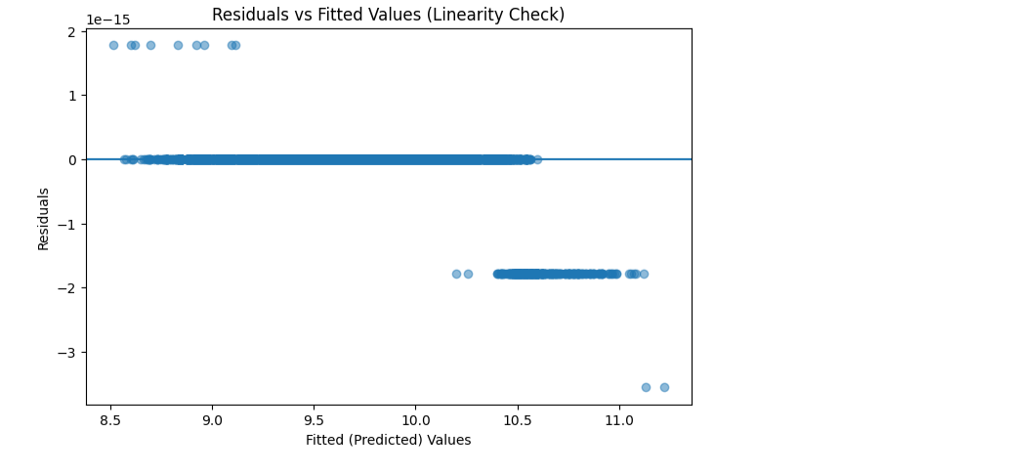



Ridge regression was implemented to address multicollinearity and improve model generalization through L2 regularization. A range of alpha values was defined using a logarithmic scale to explore both small and large regularization strengths. For each alpha, a Ridge model was trained on the reduced feature set (after removing high-VIF features), and R² scores were computed on both training and testing data. The performance trends were visualized by plotting R² scores against alpha, and the alpha value that produced the highest test R² was selected as the optimal regularization parameter, balancing bias and variance effectively.
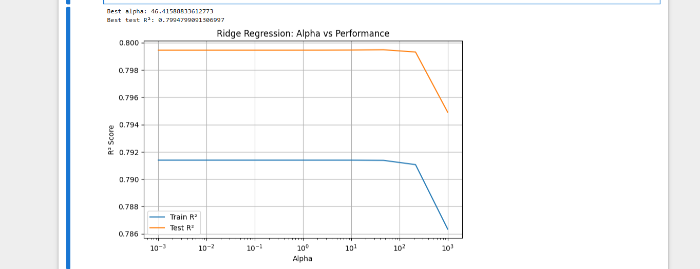

To determine the optimal regularization strength for Ridge regression, the model was evaluated using Mean Absolute Error (MAE) on the test data across a range of alpha values. For each alpha, a Ridge model was trained and predictions were generated on the test set, and the corresponding MAE was calculated. The alpha value that produced the minimum MAE was selected as the best alpha, as it represents the lowest average prediction error. This approach ensures that the chosen regularization parameter optimizes predictive accuracy on unseen data.


An initial search over a broad range of alpha values in Ridge regression provided a rough estimate of the best regularization strength by identifying the alpha with the lowest test Mean Absolute Error (MAE). To refine this estimate, a narrower range of alpha values around the initially selected best alpha was explored, creating a finer grid for evaluation. Ridge models were retrained across this refined range, and the alpha yielding the minimum MAE was chosen as the fine-tuned optimal alpha. This iterative approach ensures a more precise selection of the regularization parameter, improving model accuracy on unseen data.



The error-alpha relationship was visualized by plotting both training and testing Mean Absolute Error (MAE) against the fine-tuned range of alpha values. This graph allowed observation of how model error changes with different regularization strengths, helping to balance underfitting and overfitting. The alpha corresponding to the minimum test MAE was identified as the final optimal value, representing the regularization parameter that provides the best predictive performance on unseen data. This approach confirms the most accurate alpha within the refined search range and ensures improved model generalization.
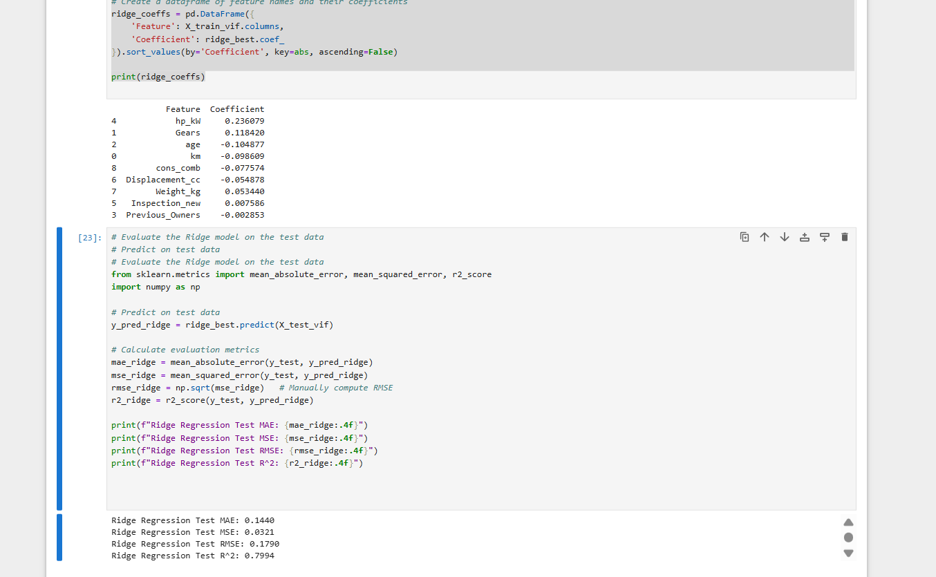
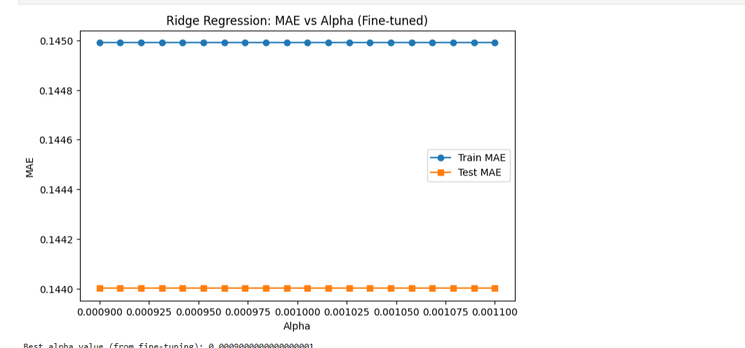

For Lasso regression, a set of alpha values was defined on a logarithmic scale to explore different levels of L1 regularization. The model was trained across these alpha values, and predictions were made on both training and testing data. Negative Mean Absolute Error (MAE) was used as the performance metric to identify the alpha that minimizes prediction error. The results were visualized by plotting train and test scores against alpha, and the alpha corresponding to the highest test score (lowest MAE) was selected as the best regularization parameter, balancing feature selection and predictive accuracy.

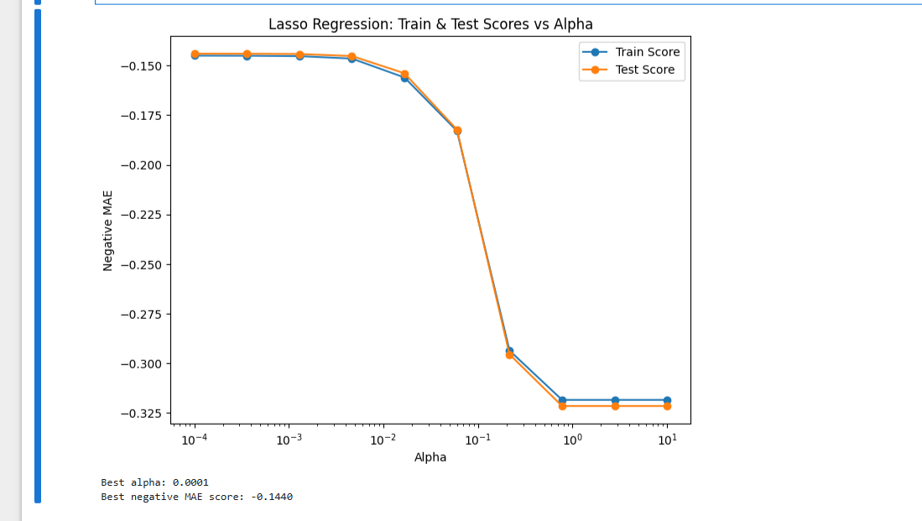

The Lasso regression model was fine-tuned by exploring a narrower range of alpha values around the initially selected best alpha. For each alpha in this refined range, the model was trained and evaluated on both training and testing sets using negative Mean Absolute Error (MAE) as the performance metric. The results were visualized by plotting train and test scores against alpha, allowing identification of the alpha that optimally balances regularization strength, feature selection, and predictive accuracy. This iterative tuning ensures a more precise choice of the L1 regularization parameter for improved model performance.
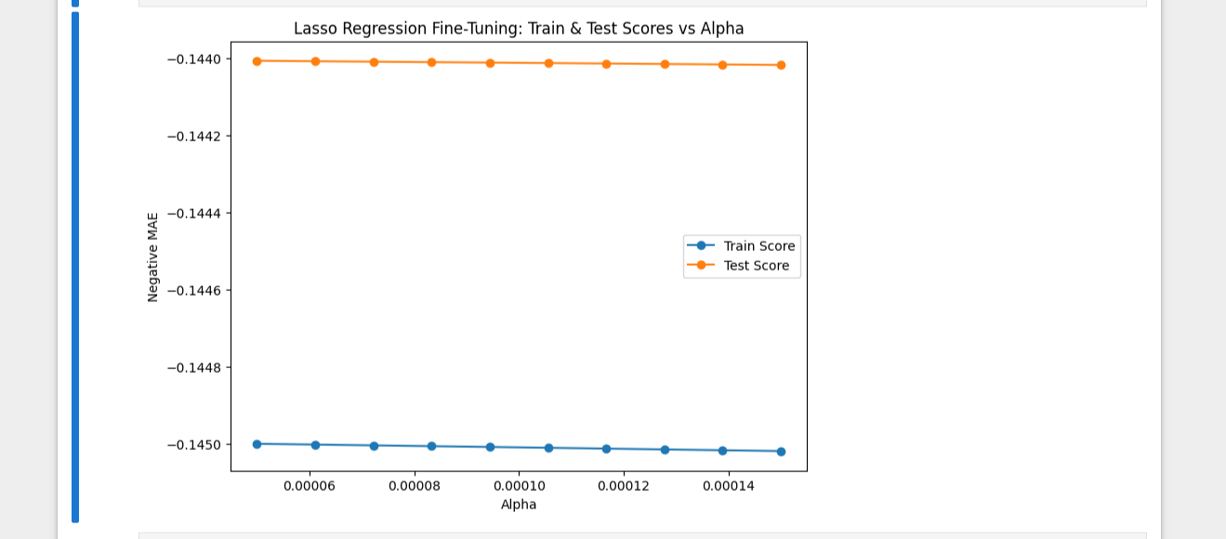

The Lasso regression model was finalized by selecting the fine-tuned alpha that yielded the lowest test Mean Absolute Error (MAE). Using this optimal alpha, the model was trained on the training data, and feature coefficients were extracted to identify the most influential predictors, with some coefficients potentially shrunk to zero due to L1 regularization. The model’s performance was then evaluated on the test set using MAE, Mean Squared Error (MSE), Root Mean Squared Error (RMSE), and R², providing a comprehensive assessment of its predictive accuracy and the effectiveness of feature selection.

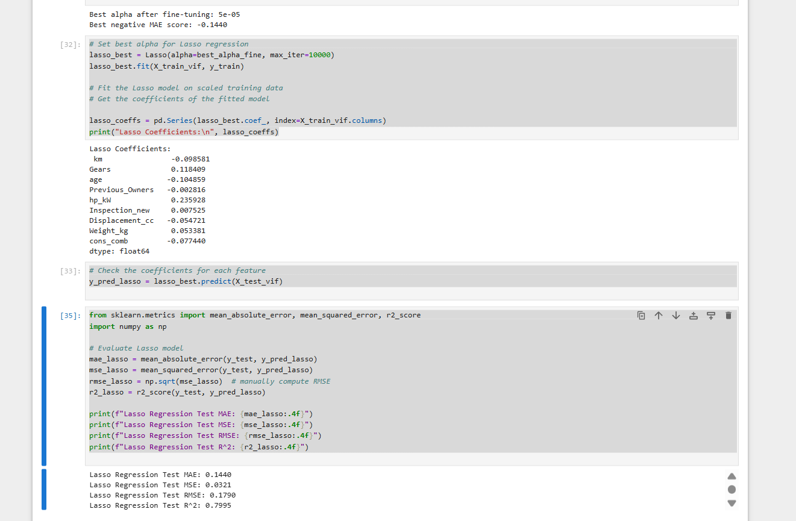

The performance of Linear, Ridge, and Lasso regression models was compared using standard evaluation metrics—Mean Absolute Error (MAE), Mean Squared Error (MSE), Root Mean Squared Error (RMSE), and R²—on the same set of features after removing multicollinear predictors. Predictions from each model were evaluated on the test set, and the metrics were compiled into a summary table for direct comparison. This analysis highlights the differences in predictive accuracy, error magnitude, and explained variance across the three models, allowing selection of the most effective regression approach for the dataset.
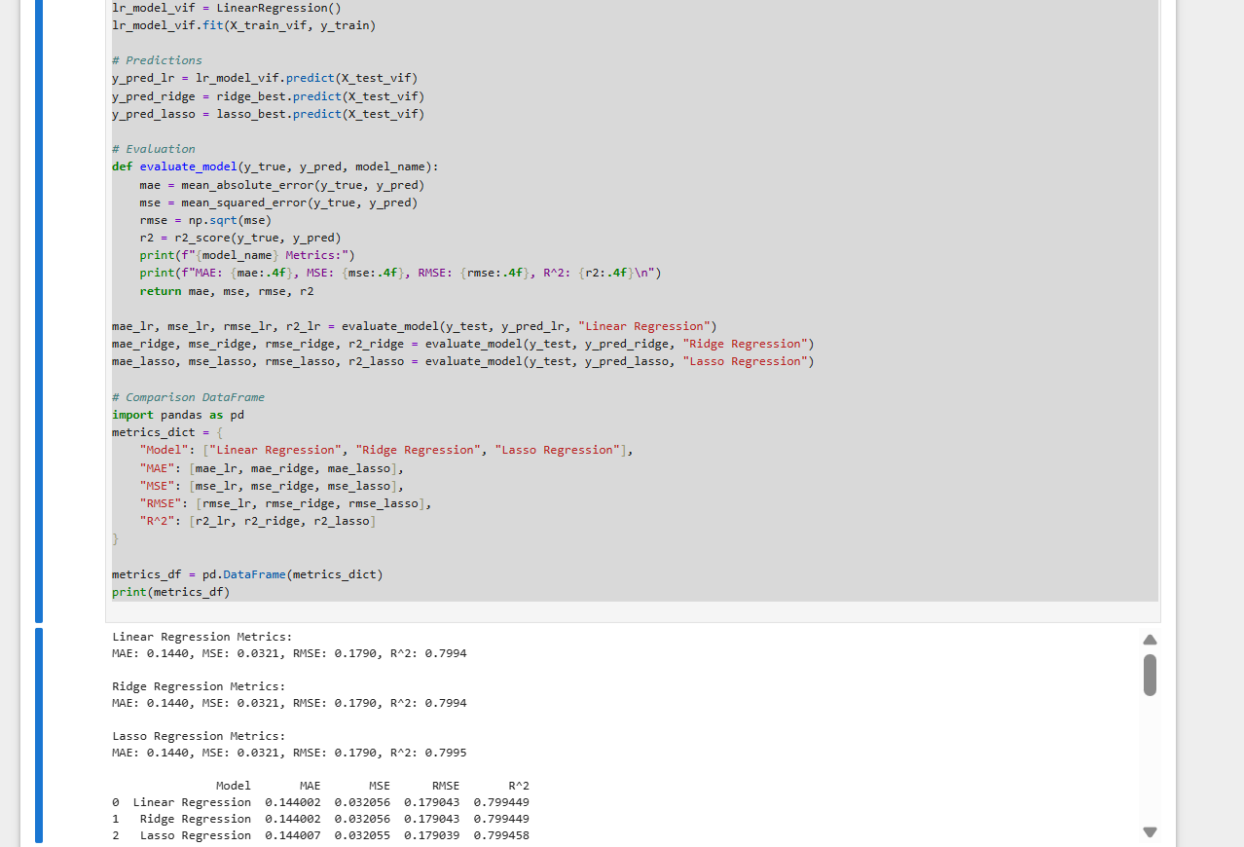

The coefficients of Linear, Ridge, and Lasso regression models were compared to understand feature importance and the impact of regularization. A dataframe was created to capture coefficients from all three models, and features with zero coefficients in Lasso were identified as eliminated due to L1 regularization. The top 10 features with the largest absolute coefficients from Linear Regression were visualized across all models, highlighting differences in magnitude and shrinkage effects. This analysis illustrates how Ridge moderates extreme coefficients, while Lasso performs both shrinkage and feature selection, providing insights into the most influential predictors and features deemed non-essential by Lasso.
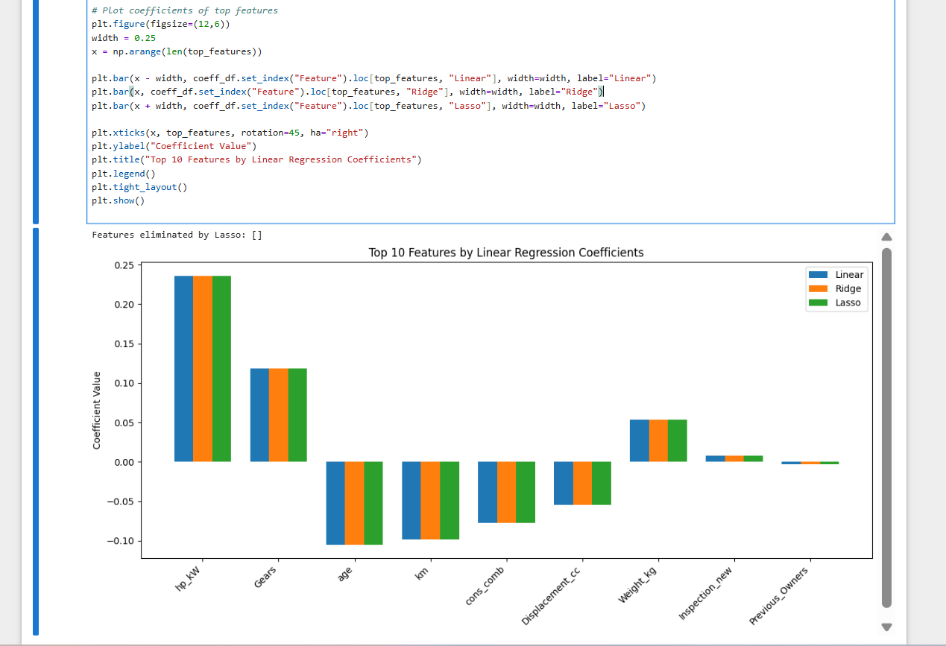

Conclusion
In conclusion, the analysis demonstrates a comprehensive approach to predicting car prices using regression models. The dataset was preprocessed with careful handling of categorical features, outliers, and feature engineering, including log-transformation of the target variable to address skewness. Linear, Ridge, and Lasso regression models were implemented and fine-tuned, with Ridge and Lasso addressing multicollinearity and performing regularization. Evaluation metrics and coefficient analysis showed that regularized models improved generalization, with Lasso additionally performing feature selection by eliminating less important predictors. Overall, the study highlights the importance of preprocessing, feature engineering, and model regularization in building robust and interpretable predictive models.

